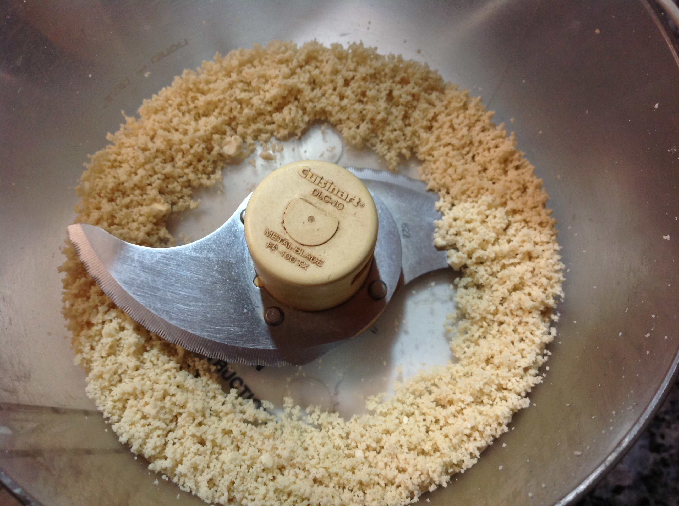
Vocabulary Word of the Day Q3 - 3: pulverize
Definition: to pound, crush, or grind to powder or dust

Part of Speech:

Conjugation – the modification of a verb from its basic form. We will also use this term to reference converting words from one part of speech to another. (none)

Example Sentence:

