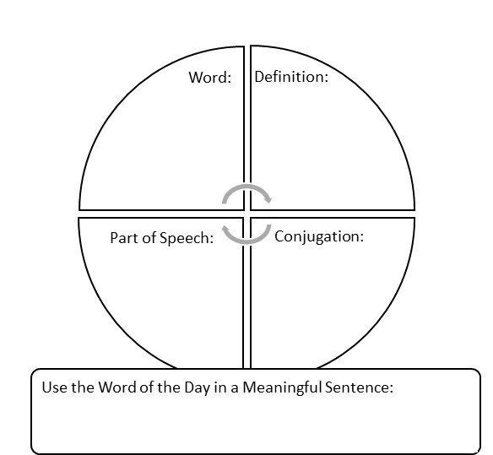

Word of the Day Graphic Organizer

Word of the Day Graphic Organizer